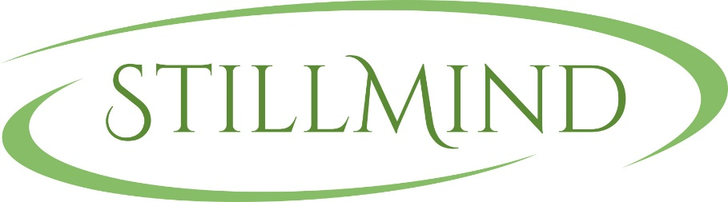

MEDITATION CLASSES BOOKING FORM
GREAT WITLEY

M. 07817466527

To: …………………………………………………………….

This is to confirm your bookings for
Wednesday 8th January
Wednesday 15th January
Wednesday 22nd January
Wednesday 29th January
Wednesday 5th February
Wednesday 12th February
Wednesday 19th February
Wednesday 26th February
Wednesday 4th March
Wednesday 11th March

From 3.00pm – 4.30pm, at a cost of £10 each. Please indicate which dates you will be attending.

Could you please pay a week in advance in order to secure your booking or if you wish to you can pay for a block of five at a time (total cost £50).

Payments can be made by either -

BACS payments to: Sort Code 77-27-15 Account Number 05270960

OR

CHEQUE: All cheques to be made payable to Sally Walker and should be addressed to 9 Ledwyche Close, Middleton, Ludlow, Shropshire. SY8 3EP

PLEASE SEND THIS FORM BACK TO ME AT sally@stillmind.me.uk

No personal details will be shared with any third party and will be destroyed after the event date.

Signed: ………………………….. Date: …………………………..

